**VESSEL EXTRACTION IN RETINAL FUNDUS IMAGES**

UCS2523 – Image Processing and Analysis   
  
Assignment 1   
Submitted By

K.Harish 3122225001036

Janeshvar Sivakumar 3122225001047



Department of Computer Science and Engineering

Sri Sivasubramaniya Nadar College of Engineering   
(An Autonomous Institution, Affiliated to Anna University)   
Kalavakkam – 603110   
October 2024

**Sri Sivasubramaniya Nadar College of Engineering**

**(An Autonomous Institution, Affiliated to Anna University)**

**BONAFIDE CERTIFICATE**

Certified that this Assignment report titled “ **VESSEL EXTRACTION IN RETINAL FUNDUS IMAGES** ” is the bonafide work of “K.Harish (3122225001036), Janeshvar Sivakumar (3122225001047) ” who carried out the project work in the Course UCS2523 – Image Processing and Analysis during the academic year 2024-25.

Internal Examiner External Examiner

Date

**TABLE OF CONTENTS**

| **S.No.** | **Topics** | **Page No.** |
| --- | --- | --- |
| **1** | Problem Statement | 1 |
| **2** | Abstract | 1 |
| **3** | Dataset Description | 1 |
| **4** | Methodology | 4 |
| **5** | Novelty | 30 |
| **6** | Sample Input and Output | 31 |
| **7** | Performance Metrics | 32 |
| **8** | Conclusion | 39 |
| **9** | References | 40 |

**1. Problem Statement**

The objective of the project is to enhance and extract blood vessel information of retinal fundus images to be used in classification tasks. This project can be used in the feature extraction process required by the mentioned classification-based machine learning models. The result of this project is an image containing the mask of the vessels in the image. The mask can further be used to highlight the vessels in the original retinal image.

**2. Abstract**

This report presents the methodology and results obtained in the process of extraction of vessel structures in retinal images. Several image sharpening techniques, smoothing techniques and morphological transformations were considered and through careful trial and error method by considering evaluation metrics and visual characteristics , the optimal methodology was obtained. The metrics for each image enhancement filter included peak signal to noise ratio (PSNR) Contrast Change Index (CCI) and Entropy . Further, for the final image ( vessel mask) obtained using morphological operations and gray level slicing Structural Similarity Index (SSIM), Dice Coefficient (Dice Score) and Intersection over Union (IoU).

## **3. Dataset Description**

The Retina Blood Vessel Segmentation Dataset from kaggle contains high-resolution retinal fundus images designed for developing and evaluating advanced blood vessel segmentation algorithms. This dataset plays a crucial role in retinal vascular disease analysis, contributing to the early detection of conditions like diabetic retinopathy and macular degeneration.

* The dataset consists of images with varying dimensions, ranging from smaller to larger pixel resolutions, providing a real-world variety in retinal imaging.

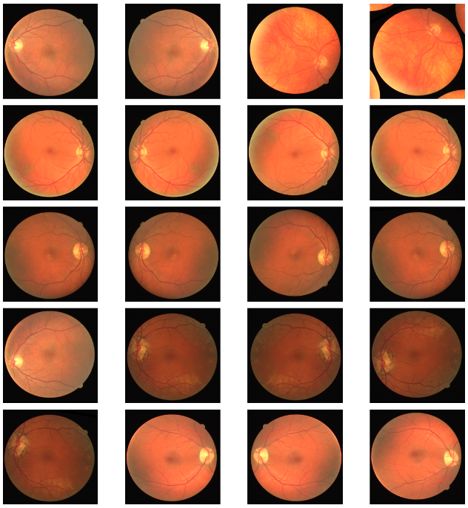

* Each image is paired with a binary mask annotation that marks blood vessel pixels as 1 and background pixels as 0. These pixel-level annotations ensure precise segmentation of retinal vessels.

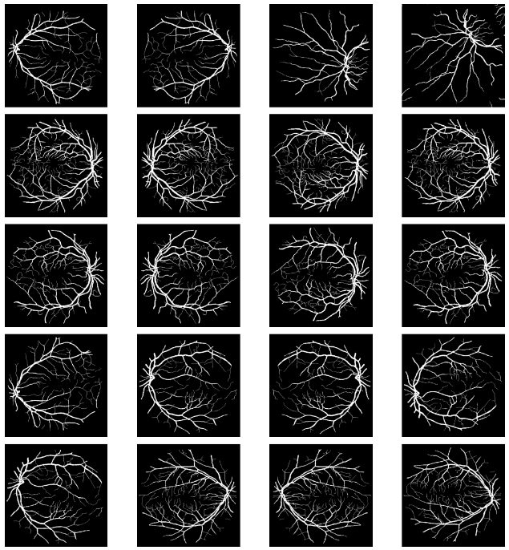

* The dataset covers a diverse range of retinal pathologies, including variations in vessel width, branching patterns, and the presence of anomalies, ensuring that segmentation algorithms can be tested under varied conditions.

Dataset link: <https://www.kaggle.com/datasets/abdallahwagih/retina-blood-vessel>

**4. Methodology**

**Techniques considered:**

**Input Image Preprocessing:**

* The green channel of the retinal image is extracted for the task, as this channel provides the highest contrast between vessels and the background.

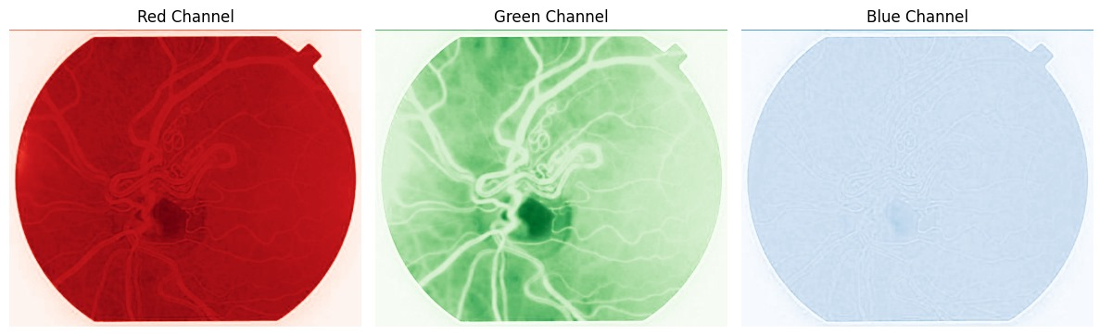

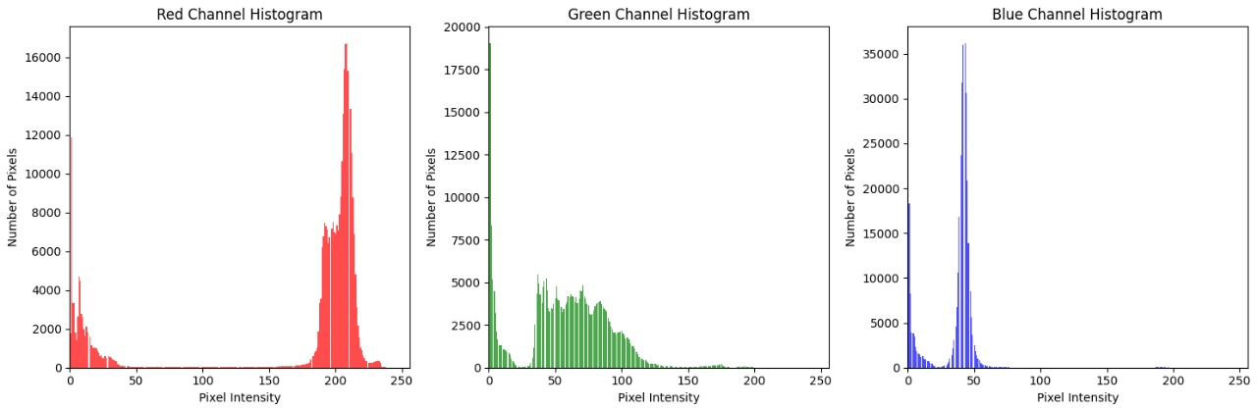

**Image Sharpening:**

* Histogram equalization: Histogram Equalization is a technique used to enhance the contrast of an image by effectively redistributing its intensity values.

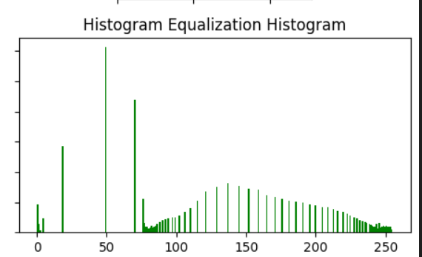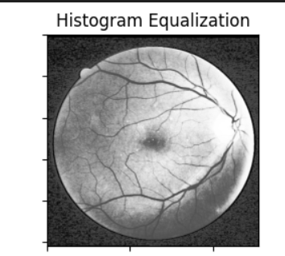

* Adaptive Histogram Equalization: Adaptive Histogram Equalization (AHE) is an advanced technique for enhancing image contrast, particularly useful in situations where the global histogram equalization may not yield satisfactory results due to varying illumination across the image.

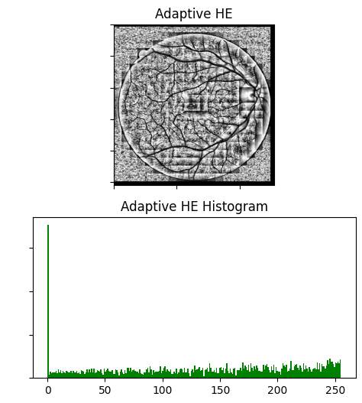

* Contrast Limited Adaptive Histogram Equalisation: Contrast Limited Adaptive Histogram Equalization (CLAHE) is an improved version of Adaptive Histogram Equalization (AHE) designed to overcome the problem of noise amplification.

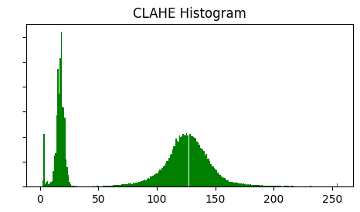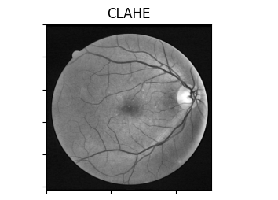

* Gamma Correction: Gamma correction is a nonlinear operation used to adjust the brightness or luminance of an image.

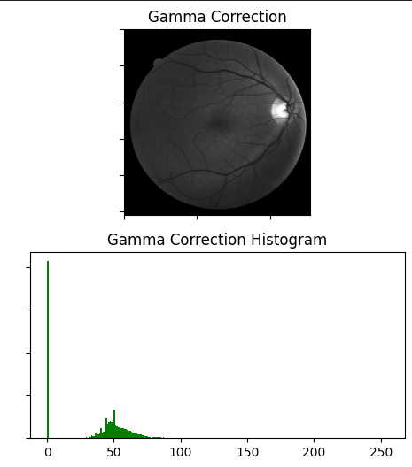

* Unsharp Masking: Unsharp masking is an image sharpening technique used to enhance the edges and fine details in an image.

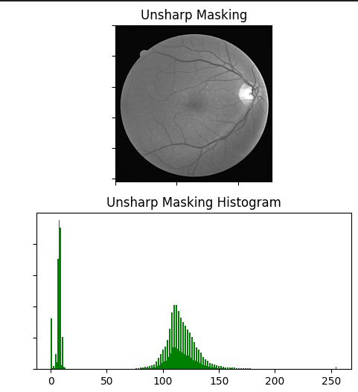

* Logarithmic Transformation: Logarithmic transformation is a non-linear image enhancement technique used to expand the darker regions and compress the brighter regions of an image

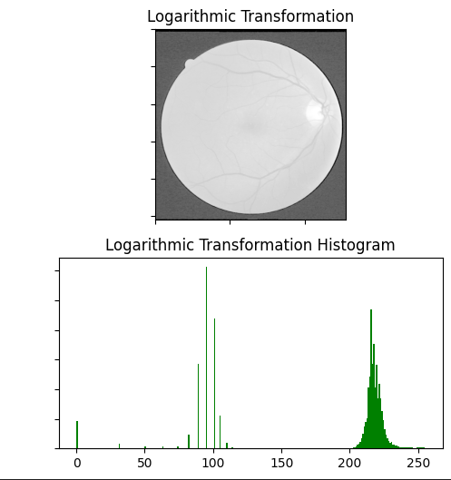

* Exponential transformation: Exponential transformation is a non-linear image enhancement technique that is the inverse of logarithmic transformation. While logarithmic transformation enhances darker areas and compresses brighter areas, exponential transformation does the opposite—it enhances the brighter areas of an image and compresses the darker areas.

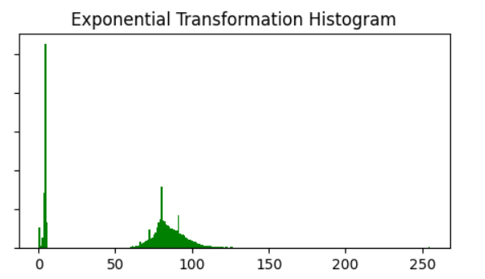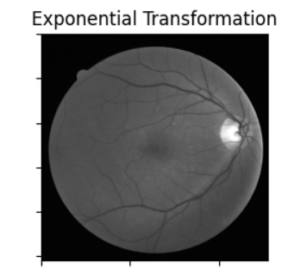

* Laplacian Filter:A Laplacian filter is a second-order derivative filter used to highlight areas of rapid intensity change, often used for edge detection. The Laplacian operator calculates the second derivative of the pixel intensity values in an image, which identifies regions where the intensity changes abruptly (i.e., edges). It’s typically applied to grayscale images.

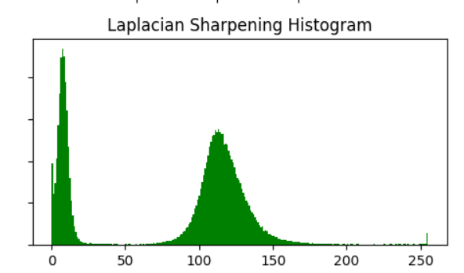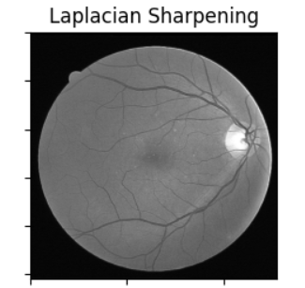

| **FILTER** | **PSNR** | **CII** | **ENTROPY** |
| --- | --- | --- | --- |
| Histogram Equalisation | 12.845 | 1.3303 | 3.789 |
| Adaptive Histogram Equalisation (AHE) | 7.889 | **1.489** | 5.343 |
| CLAHE | 25.033 | 1.024 | 4**.**541 |
| Gamma Correction | 13.821 | 0.582 | 3.303 |
| **Unsharp Masking** | **37.741** | 1.013 | 3.899 |
| Logarithmic Transformation | 8.402 | 1.141 | 3.272 |
| Exponential Transformation | 20.047 | 0.782 | 3.673 |
| **Laplacian Sharpening** | **29.818** | 1.014 | **4.405** |

**Vessel detection - Matched Filtering:**

* Matched filtering is an image processing technique used to detect the presence of a known structure in a given environment.
* Retinal vessels are not linear, they vary in their orientation and thickness throughout their structure.
* To capture this wide range of vessel structures, a simple horizontal or vertical filter to detect the edge will not be helpful, hence we iterate through all possible angles.
* For this a gobar Kernel is used as the know structure in matched filtering.

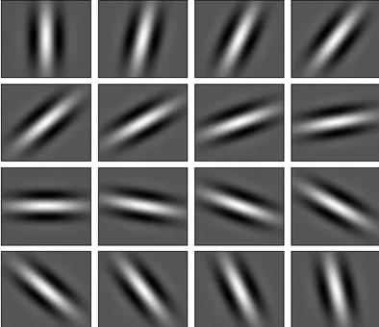

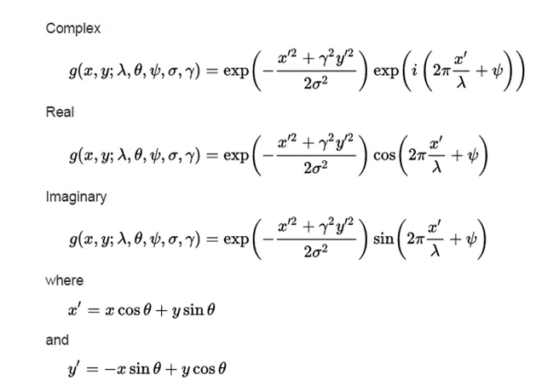

In the above equation,

λ — Wavelength of the sinusoidal component.

Ө — The orientation of the normal to the parallel stripes of the Gabor function.

Ψ — The phase offset of the sinusoidal function.

σ — The sigma/standard deviation of the Gaussian envelope

ɣ — The spatial aspect ratio and specifies the ellipticity of the support of the Gabor function.

* Different kernel sizes are used to detect different thickness of vessels.
* The maximum response across all angles and scales is computed to highlight vessels while suppressing non-vessel structures.

**Noise Reduction:**

The type of noise that was prevalent in the dataset was speckle noise - resulting from contrast enhancement which increased the intensity of the inherent noise in medical imaging.

* Non Local Means Filter: A denoising technique that averages similar pixel values from a larger neighborhood, effectively reducing noise while preserving image details.

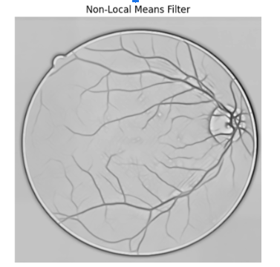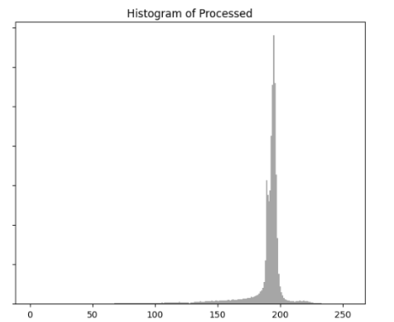

* Adaptive Median Filter: A noise reduction filter that replaces a pixel's value with the median of its surrounding pixels, adapting to local noise conditions to preserve edges.

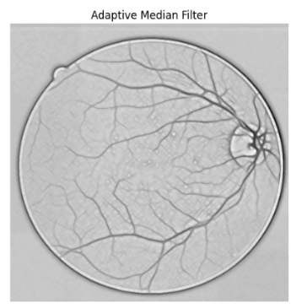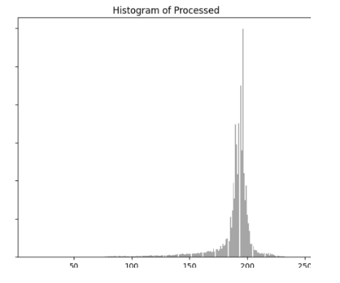

* Gaussian Low pass filter: A frequency domain filter that attenuates high-frequency components in an image while allowing low-frequency components to pass, resulting in a smooth image.

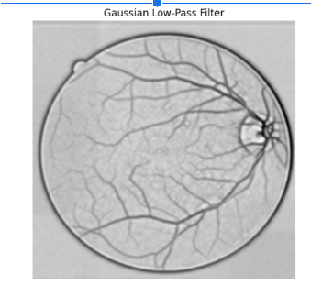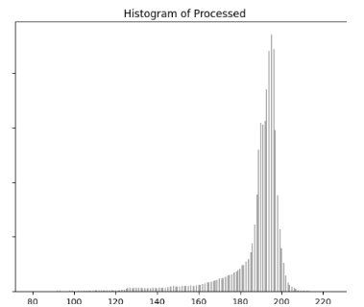

* Butterworth low pass filter: A type of frequency domain filter characterized by a smooth frequency response, which attenuates high frequencies without introducing ripples in the passband.

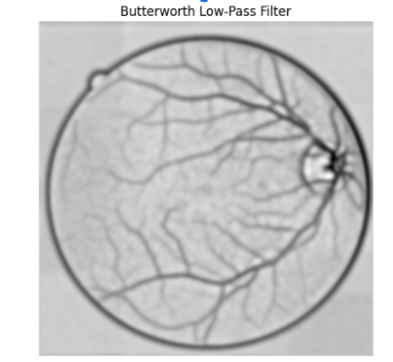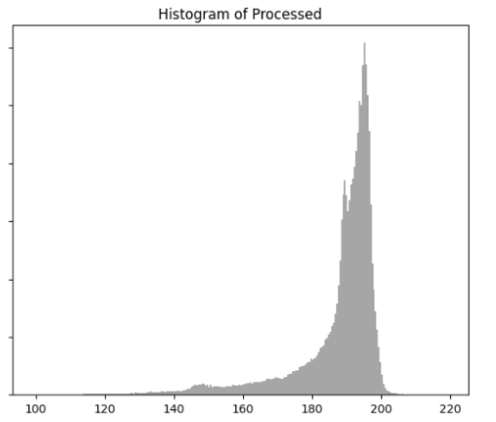

* Mean Low pass filter: A simple averaging filter that replaces each pixel value with the mean of its neighboring pixels, effectively blurring the image and reducing high-frequency noise.

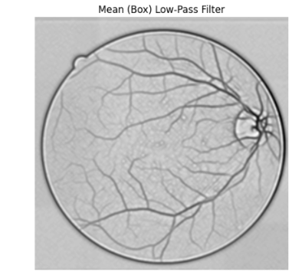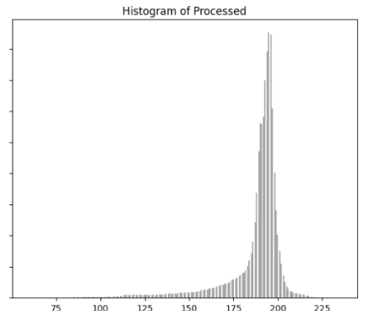

| **FILTER** | **PSNR** | **CII** | **ENTROPY** |
| --- | --- | --- | --- |
| Non Local Means Filter | **36.964** | **1.000** | 4.955 |
| Adaptive Median Filter | 36.445 | 0.922 | **5.333** |
| Gaussian Low pass filter | 32.627 | 0.588 | 5.076 |
| Butterworth low pass filter | 23.872 | -0.529 | 4.951 |
| Mean Low pass filter | 33.362 | 0.698 | 5.273 |

**Morphological Operations:**

We are using morphological closing which includes the following steps:

* Dilation: Expands the boundaries of foreground objects, filling small holes and connecting nearby objects.
* Erosion: Shrinks the expanded objects back down, effectively removing small gaps and noise while preserving the overall shape of the larger structures.

Morphological closing is done to remove boundary noise that was found in the dataset.

**Adaptive Thresholding:**

Adaptive Thresholding Converts the grayscale image to binary image by considering the local threshold whose region is defined as a parameter. The threshold is calculated as the mean of the pixel values in the local neighborhood around the pixel.

**Image Processing Approaches:**

1. First Approach:

Through empirical data it was found that reducing noise before applying laplacian severely deteriorates the quality of the image.

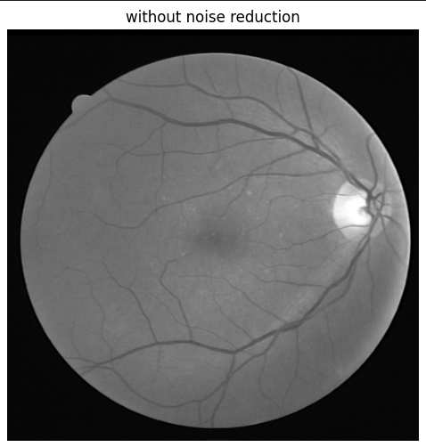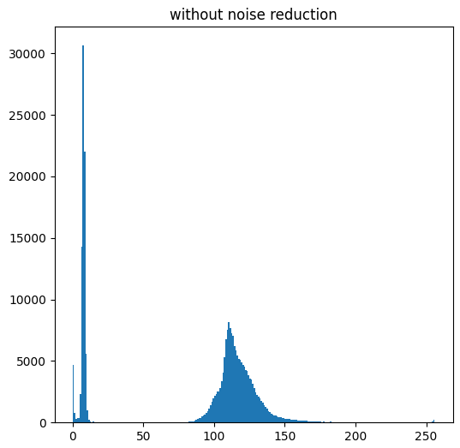

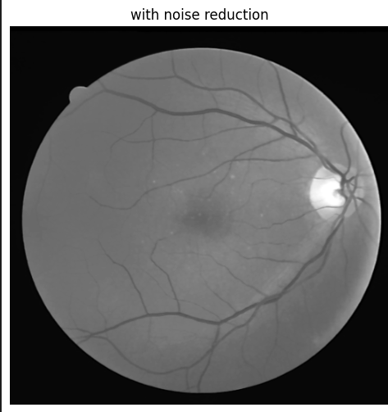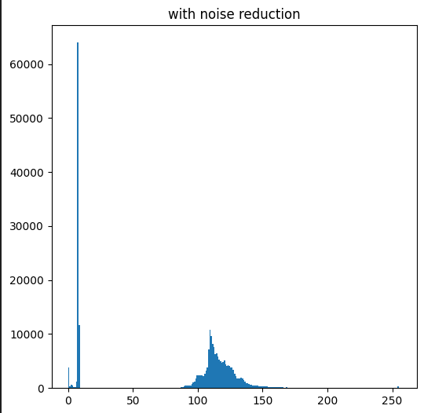

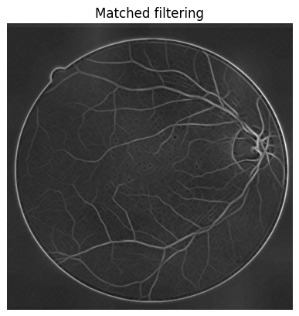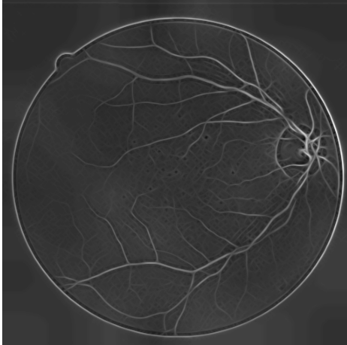

The left image(no initial noise reduction) contains a lot more minute vessel structure compared to the right image( noise reduced). Furthermore all the vessels are relatively more structured and defined in the left image thus proving the necessity to not apply any noise reduction prior to vessel detection.Here we found out, empirically that applying an noise reduction filter results in too much of a contrast loss and a lot of the information in the image.

Sharpening prior to laplacian also leads to noise increase and noise corruption.

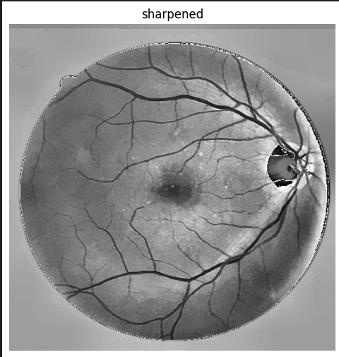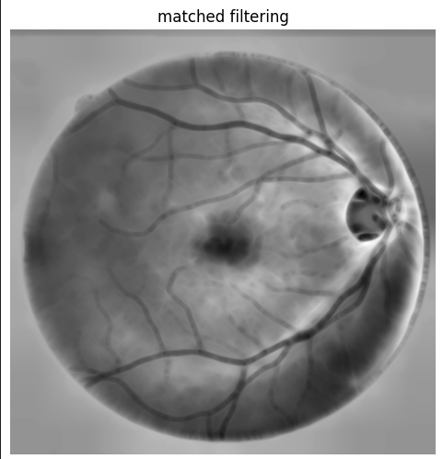

even though reapplying laplacian on the image to sharpen/highlight the vessels, it also enhances any region of rapid intensity increase/decrease which further increases the noise and the artifacts around the vessel. Further other artifacts like Fovea Centralis and the optic disk are also enhanced.since laplacian filter is a high pass filter it enhances edges and noises and enhancing/sharpening the image would further amplifies the noise.

Another finding is that applying inversion does not change the outcome of the matched filter since the filter essentially highlights edges and the laplacian in itself identifies the borders only and not enhances them.

Hence the green channel Image was directly fed into the laplacian filter.Laplacian filter was chosen as it is good at detecting regions of rapid intensity change, thereby highlighting the edges of the vessels.

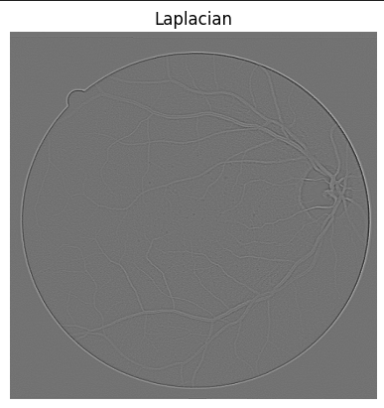

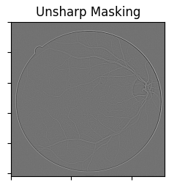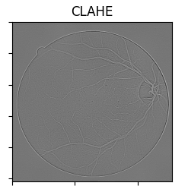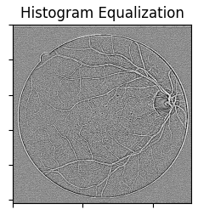

| **FILTER** | **PSNR** | **CII** | **ENTROPY** |
| --- | --- | --- | --- |
| Histogram Equalisation | 10.9 | **8.9** | 2.95 |
| CLAHE | 28.22 | 1.91 | **4.01** |
| Unsharp Masking | **35.95** | 1.48 | 3.26 |

To further improve the contrast between the foreground and background, CLAHE was used. All image enhancement techniques were chosen through trial and error method by considering metrics and perceptive quality.All the above enhancement techniques were used to prepare the image for vessel extraction. Although the laplacian is good at edge detection, it does not provide a concrete and specific identification of vessels. This can only be achieved through using a filter that can correlate with the varying thickness and orientation of the vessels. Hence a matched filter using a Gobar Kernel is used. The kernel is rotated through 360 degrees to cover all the orientations of the vessels.

To further improve the contrast without increasing the noise or reducing the edge quality, an unsharp filter was used.

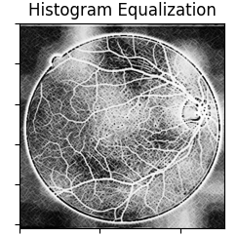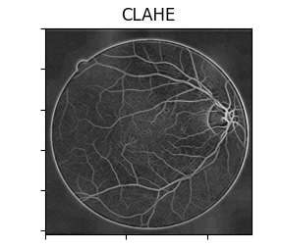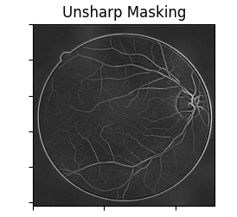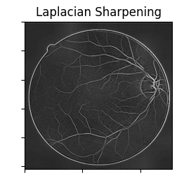

| **FILTER** | **PSNR** | **CII** | **ENTROPY** |
| --- | --- | --- | --- |
| Histogram Equalisation | 8.066 | **4.013** | 3.44 |
| CLAHE | 24.07 | 1.46 | **4.26** |
| Unsharp Masking | **32.34** | 1.29 | 3.64 |
| Laplacian Sharpening | 25.29 | 1.55 | 4.00 |

To remove the noise around the vessel edges a morphological closing transformation which comprises dilation followed by erosion is used.Before binarizing the image , a non-local means filter is used to remove any and all noises that were generated throughout the process.

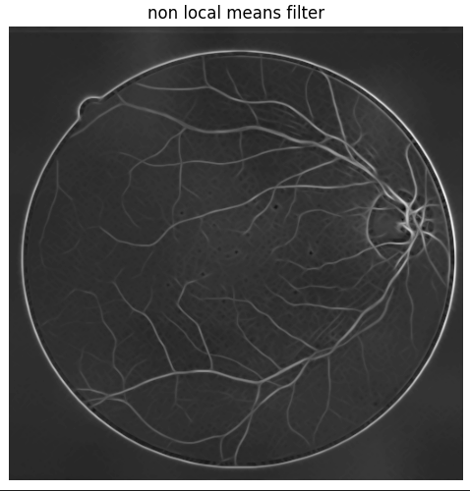

Before binarizing the image , it is first morphologically transformed to smooth boundaries to remove artifacts that interfere with the vessel extraction process.

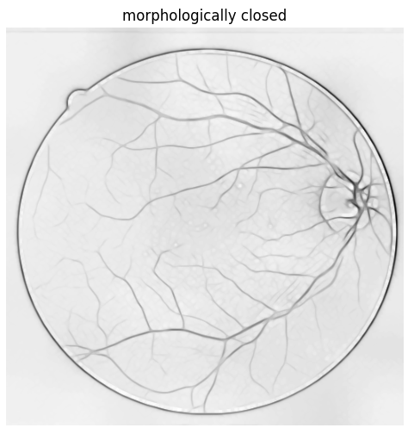

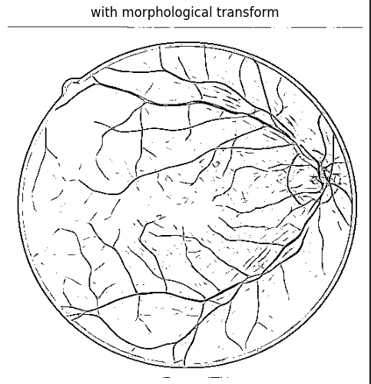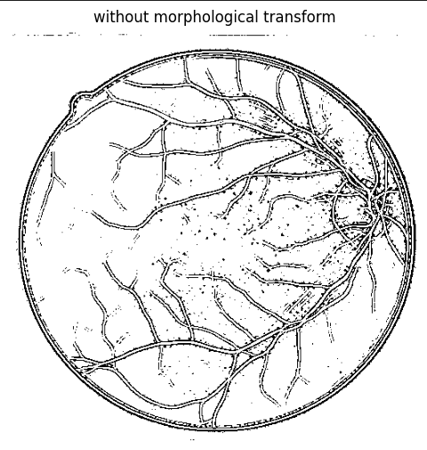

It is clear that the minute noise around hinders the thresholding operation thereby resulting in a poor quality mask.

Finally an adaptive filter is used to binarize the image.

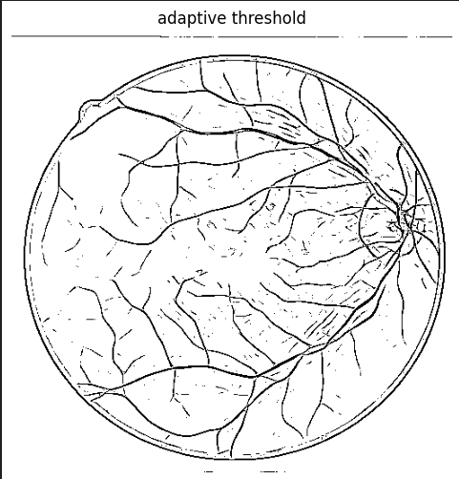

To utilize the hand labeled masks as reference we invert the image for evaluation metrics.

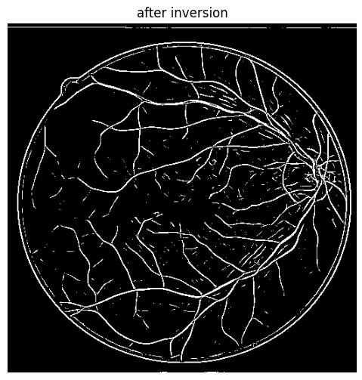

Once the binary image is generated, the Connected Set operation is applied.The operation identifies connectivity in the image and assigns labels to them. Further, to remove noisy-sets we set a threshold on the number of pixels in each set.

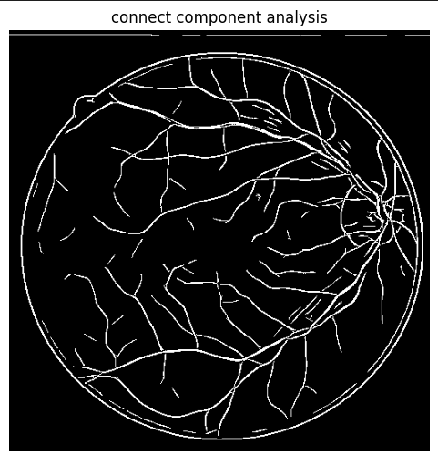

**Steps Involved:**

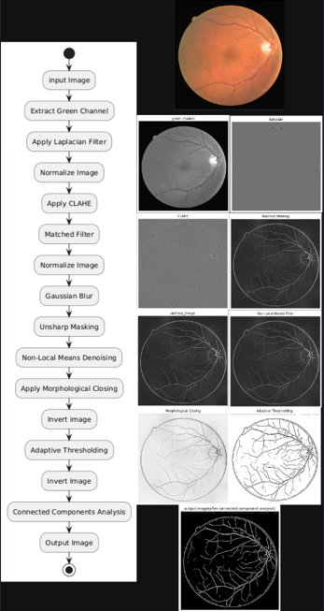

1. **Second Approach:**

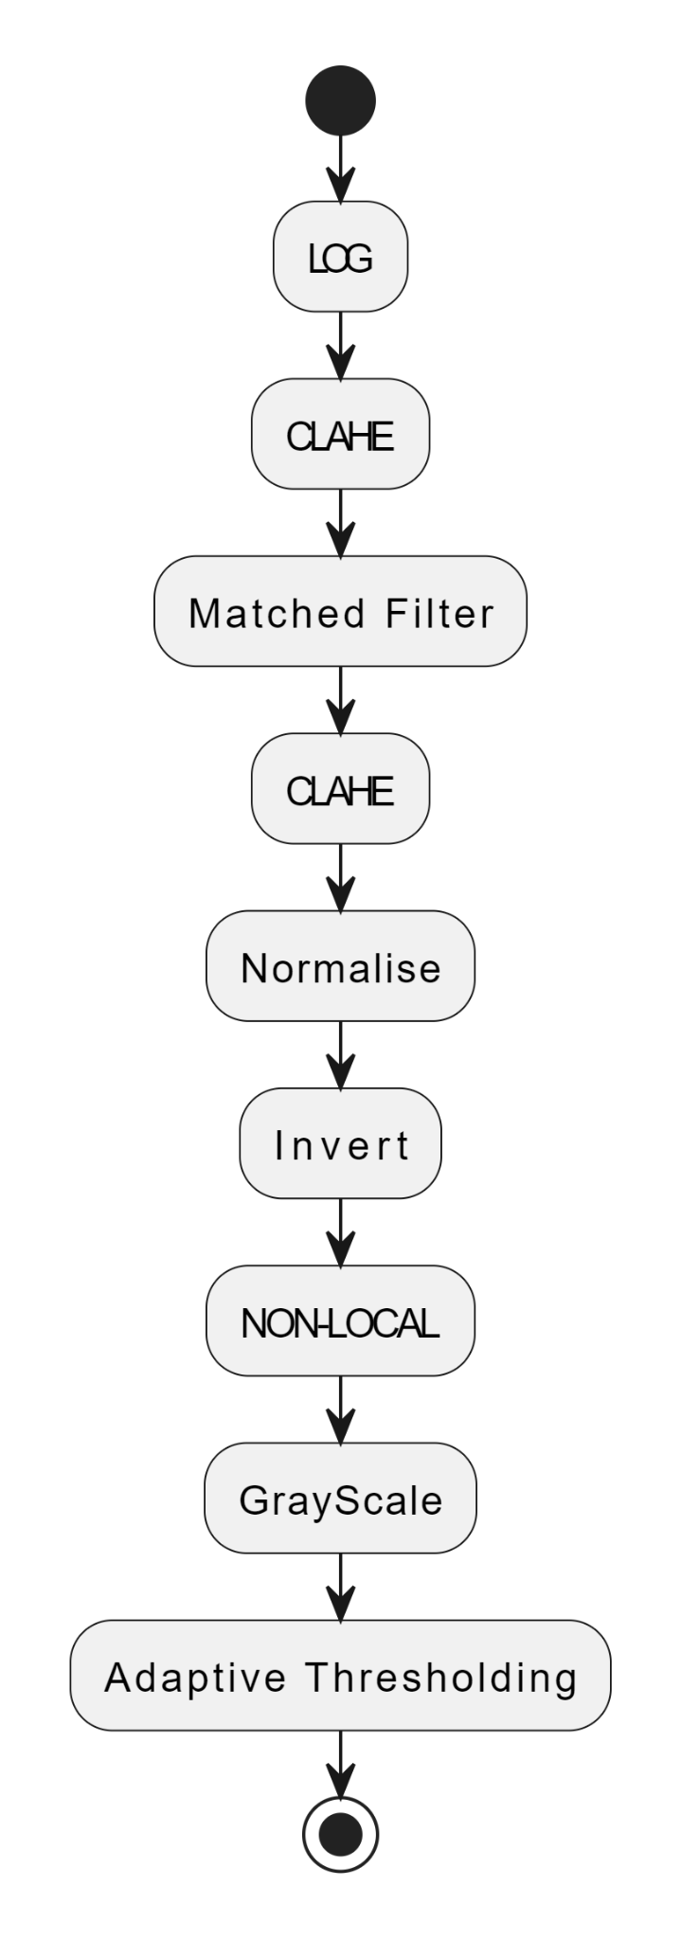

Since we need to extract the vessels from the image, any noise in the image is detrimental to the process. Applying LOG on the green channel, although does not increase the noise but the quality of the edges are slightly reduced. To reduce this effect CLAHE is used. In order to highlight the vessels we use the Matched Filter and to further increase the contrast for the final gray level slicing, CLAHE is applied again. To finally reduce the amount of noise present at the end of the process before gray level slicing , Non-Local means Filter is applied.

**Steps Involved:**

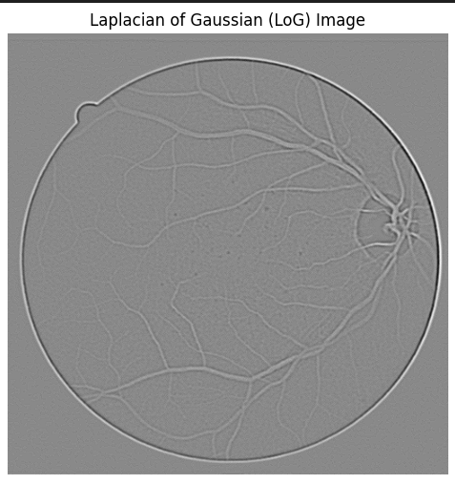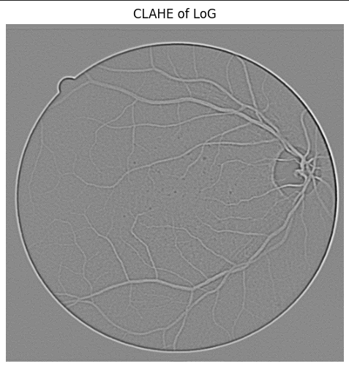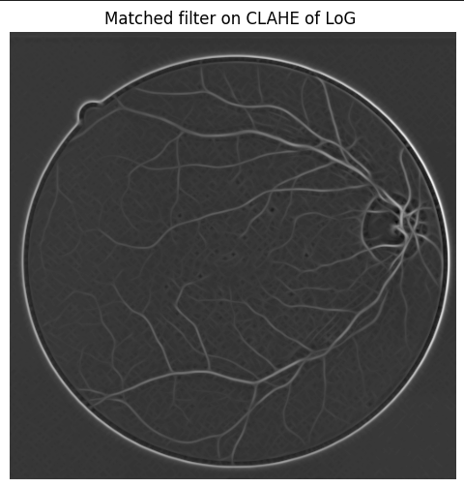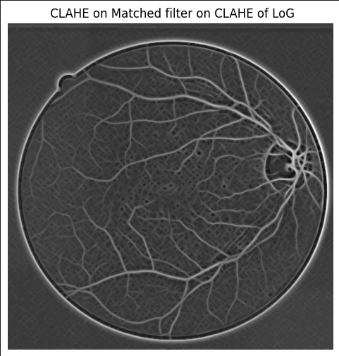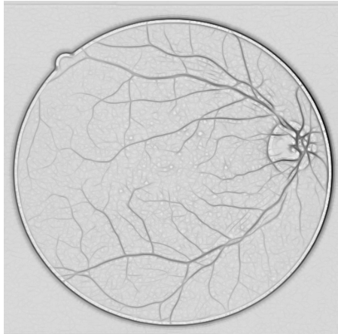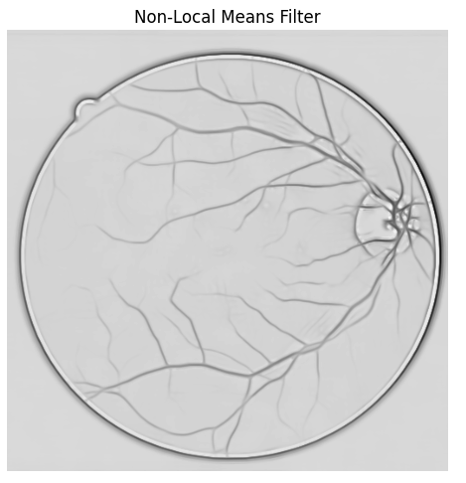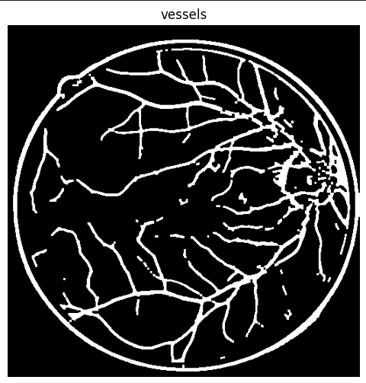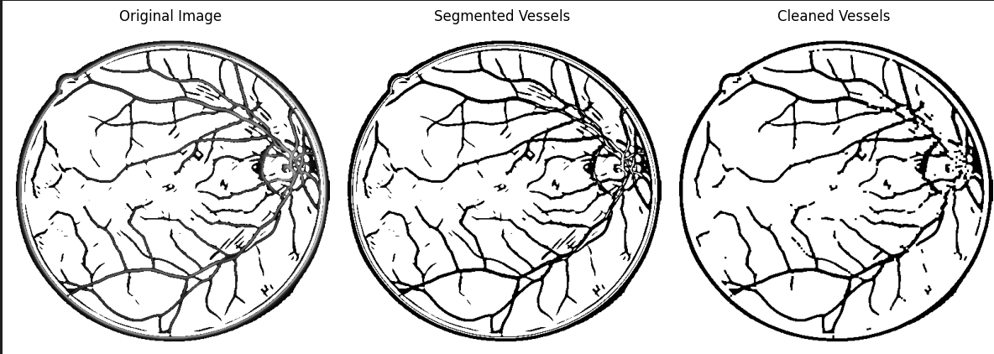

1. **Third Approach:**

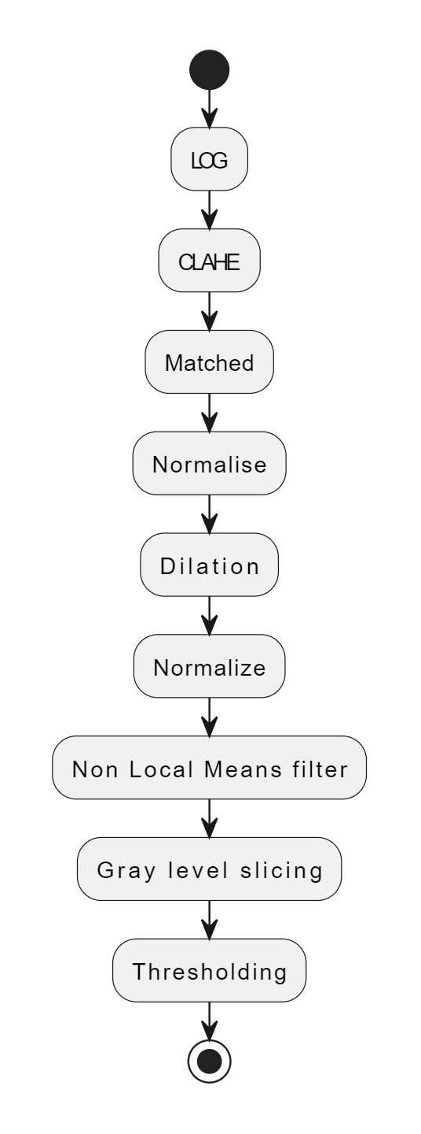

Applying LOG on the green channel, although does not increase the noise but the quality of the edges are slightly reduced. To reduce this effect CLAHE is used. In order to highlight the vessels we use the Matched Filter. Since we are using dilations prior to reducing noise, through experimentation it is found that applying a CLAHE filter is not useful.

**Steps Involved:**

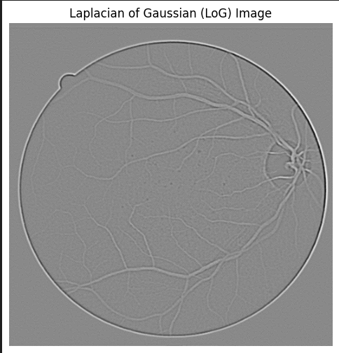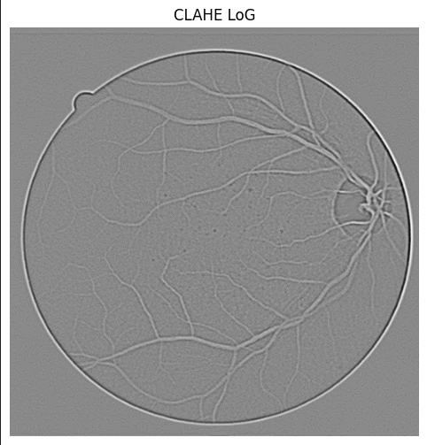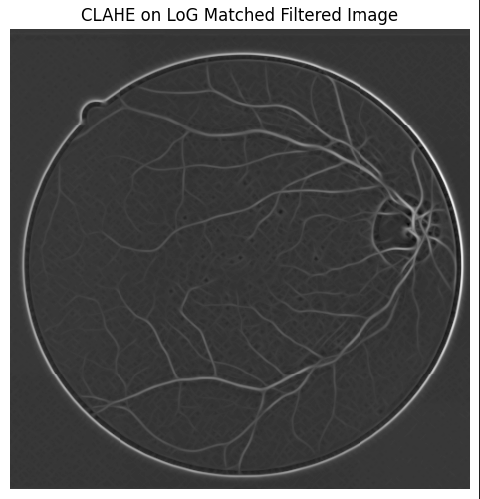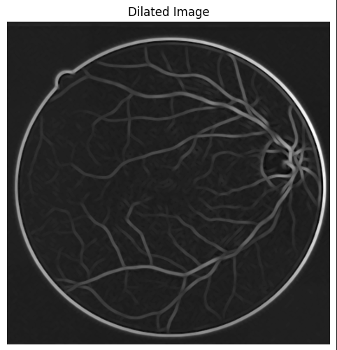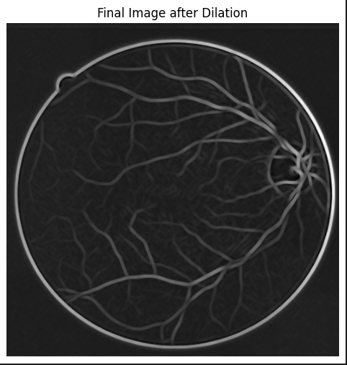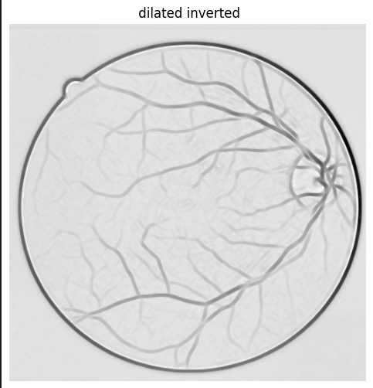

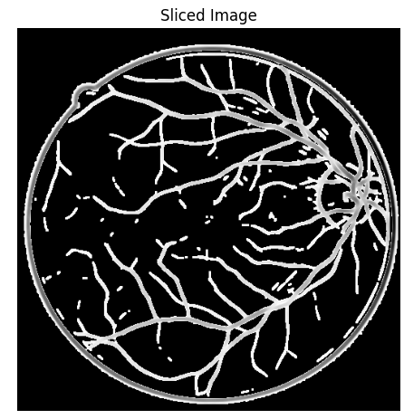

1. **Fourth Approach:** We introduced a gaussian blur before applying the laplacian to remove noise. This resulted in the loss of edge information.

**Steps Involved:**

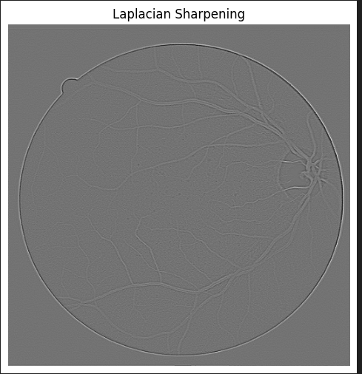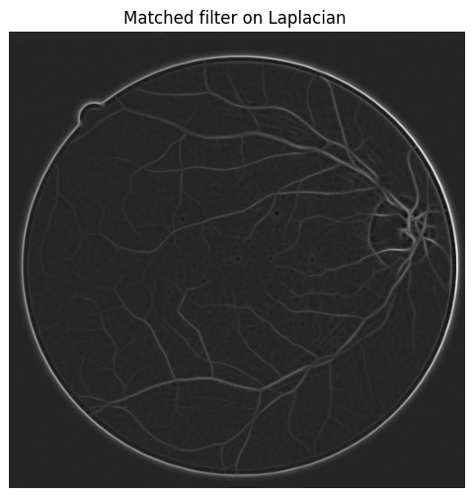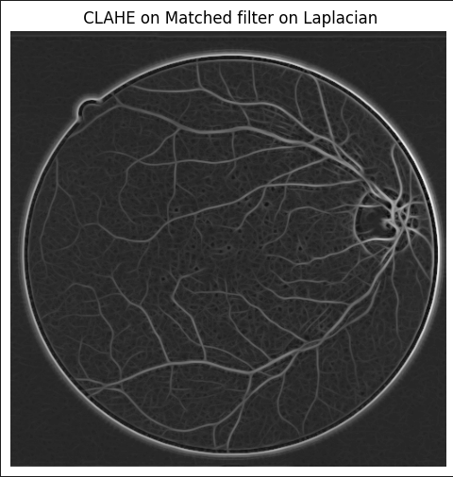

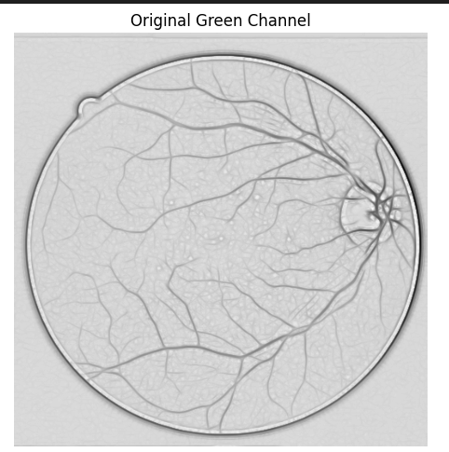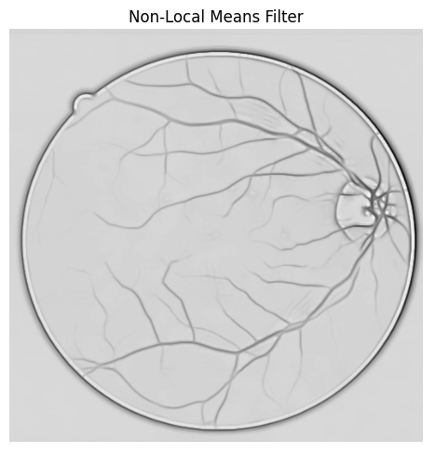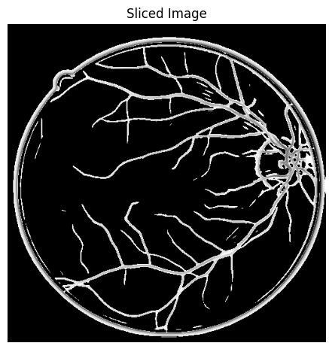

**Comparing 4 Approaches:**

**1 2**

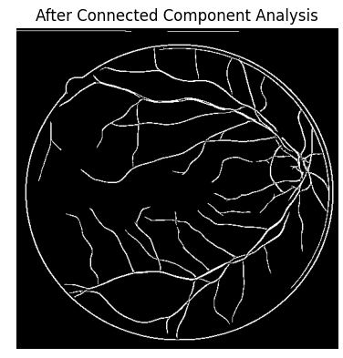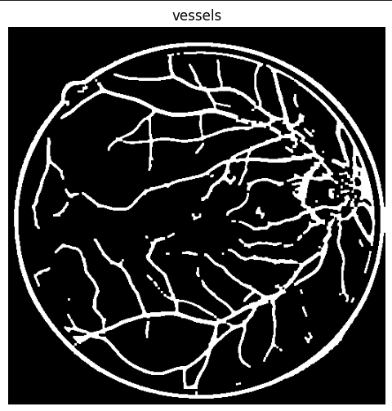

**3 4**

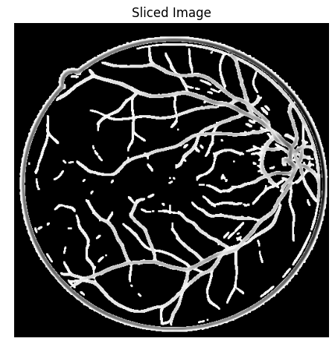

**5. Novelty**

Research on vessel extraction has relied on manual labeling followed by machine learning algorithms.

Work on image processing has essentially focused on Speeded Up Adaptive Contrast Enhancement (SUACE) which is a modification of the Tyler Coye Algorithm . Other methods include Histogram Equalization, Gabor wavelet, Local Normalization and Unsharp Masking, Wavelet, Contourlet and Curvelet methods separately applied to the filter.

Our novel approach introduces a combination of preexisting separate works, combined using a well empirically defined approach.

1. We extract the green channel image from the fundus image for processing
2. We apply 2 filters, essentially for intensity change detection and vessel detection. This helps in the fine tuning of the vessel extraction by reducing the dominance of unnecessary artifacts in the image.
3. A CLAHE filter between the edge and vessel detection is applied furthering the contrast of the image. This is again followed by an unsharp filter after the vessel extraction.
4. This is a S.
5. A morphological operation is performed on the image to further separate the pixel intensities of the vessels from its neighbors.
6. Segmentation includes an adaptive thresholding followed by a connected component analysis to further clean the image.

**6. Sample Input and Output**

**Input:**

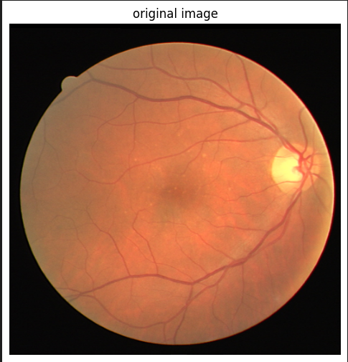

**Output:**

**Highlighted vessels output mask**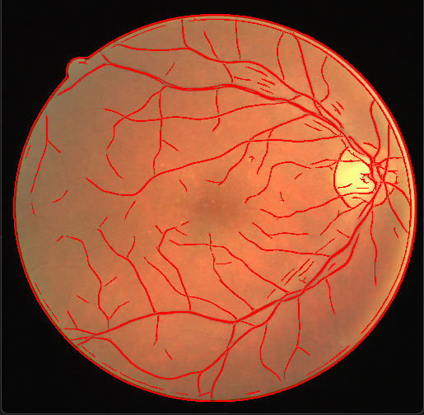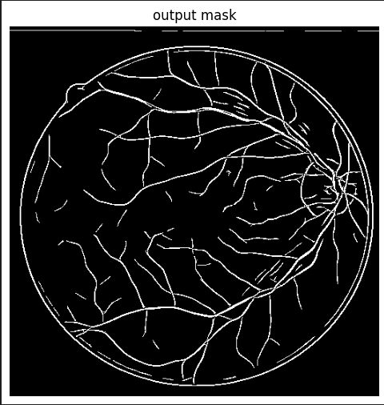

**7. Performance Metrics**

### 1. IoU (Intersection over Union):

* Definition: IoU measures the overlap between the predicted segmentation and the ground truth. It is the ratio of the intersection of the predicted and ground truth areas to their union.
* Formula:

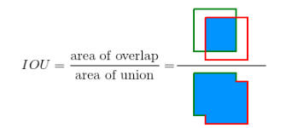

* + TP: True Positive
  + FP: False Positive
  + FN: False Negative

### 2. Dice Coefficient :

* Definition: Dice coefficient is a metric similar to IoU but is generally more sensitive to small object segmentations. It is the harmonic mean of precision and recall.

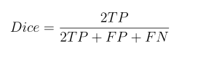

### 3. Precision:

* Precision is the ability of a model to identify only relevant objects. It is the percentage of correct positive predictions.

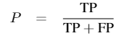

### 4. Recall:

* Recall is the ability of a model to find all relevant cases (all ground-truth bounding boxes). It is the percentage of correct positive predictions among all given ground truths.

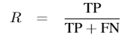

### 5. Accuracy:

* Accuracy is the proportion of correct predictions (both true positives and true negatives) out of all predictions made.

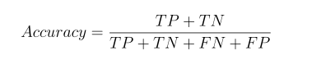

6. Peak Signal-to-Noise Ratio (PSNR):

* PSNR is a measure used to assess the quality of reconstructed or compressed images compared to the original image. It quantifies the ratio between the maximum possible power of a signal (the original image) and the power of corrupting noise (the differences between the original and compressed images).

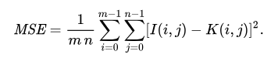

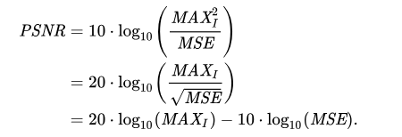

MAX is the maximum possible pixel value of the image.

### 7. CII (Colorfulness Index Indicator):

* CII is a metric used to quantify the colorfulness of an image. It measures the intensity and variety of colors in an image, considering both saturation and brightness.

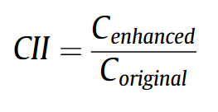

C enhanced and C original denote the contrast of the enhanced and original images, respectively.

### 8. Entropy:

* Entropy in image processing refers to a measure of the amount of information or uncertainty contained in an image. It quantifies the randomness or complexity of pixel values in the image. Entropy can be used to judge image quality because greater entropy values often reflect more detailed and complex images.
$H(X)=−i=1∑N​p(xi​)⋅log2​(p(xi​))$

* H(X) is the entropy of the image.
* $p(xi​)$ is the probability of occurrence of pixel value $xi$
* N is the total number of unique pixel values.

**Evaluating Filters:**

* Optimizing the Laplacian Filter

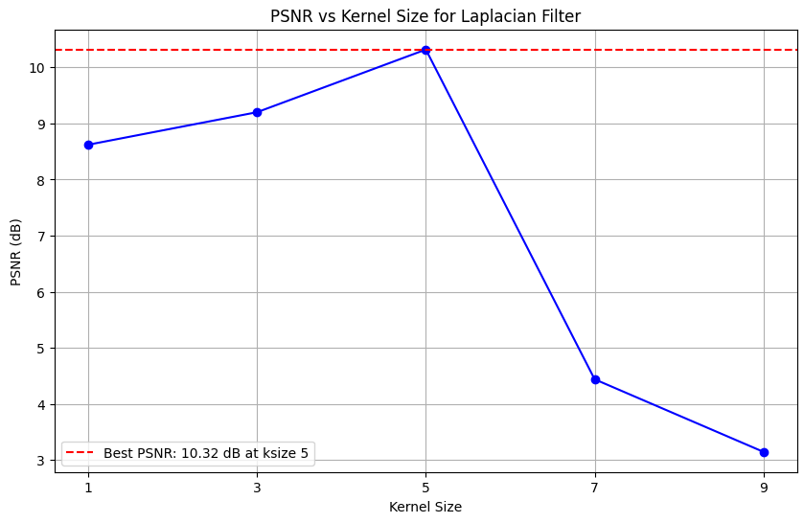



* Optimizing Contrast Limited Adaptive Thresholding Filter

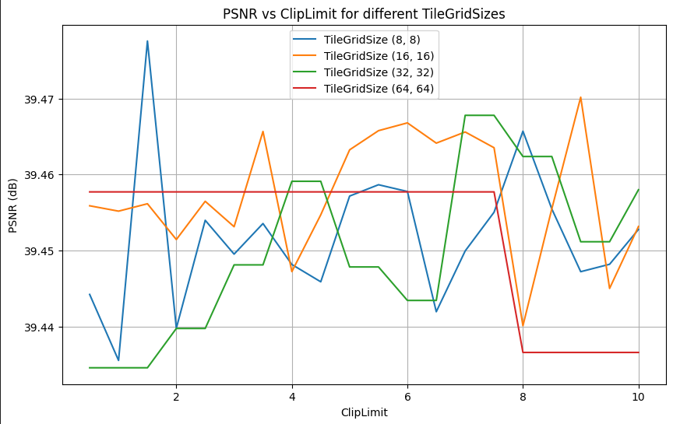



* Optimizing the Matched Filter

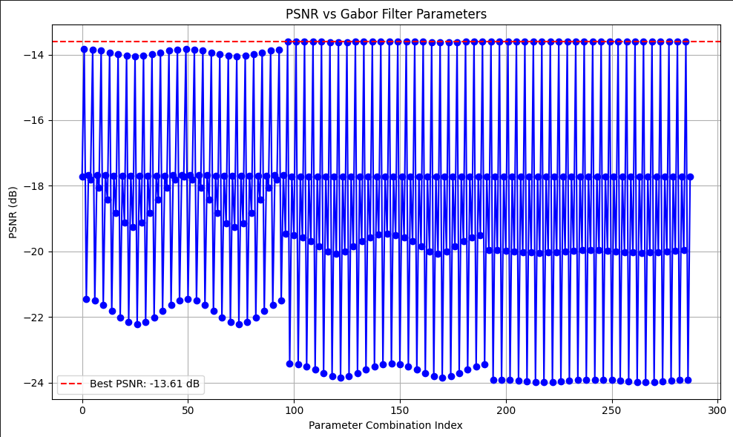 

* Optimizing the unsharp masking Filter

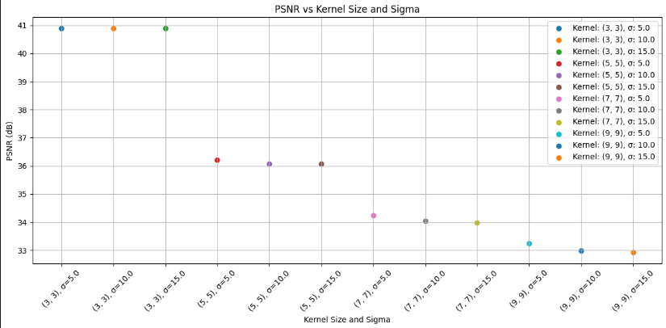



* Optimizing the Non local Means Noise Filter

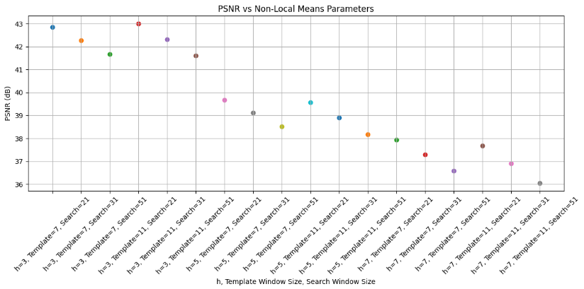



Comparing Final Mask with hand labeled Mask

****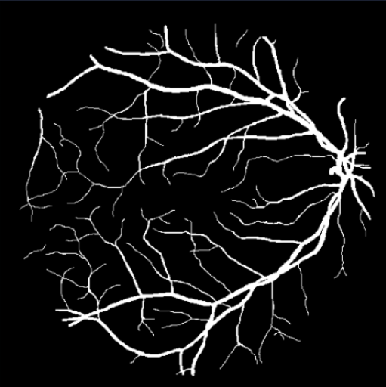

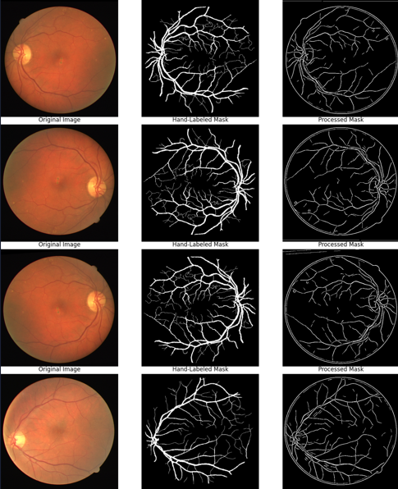

The processed mask and hand labeled mask is compared and evaluated based on their IoU, Dice Coefficient, Precision, Recall and Accuracy. All the images in the dataset are compared and average metrics across the dataset is obtained.

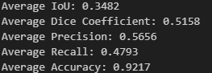

The mask is more conservative in identifying positives but misses some true positive regions.

The mask performs well overall in terms of predicting both classes (positive and negative) pixels - the vessel structures.

**Future improvements:**

1. To further enhance the vessel structure quality , an edge linking process can be implemented
2. In a few images the corneal structure is retained.
3. Since the dataset contains no circumferential artifact , image preprocessing can be done to increase the accuracy of the evaluation metrics. This can be done by applying a mask on the input image. Since the exact positioning of each image was not accurate and there exists a small variation in the retinal size , the results were not positive enough to be implemented.

**8. Conclusion**

The complete process has been thoroughly been experimented and obtained for retinal blood vessel extraction by utilizing various image processing techniques. The obtained results are compared with the hand labeled masks in the dataset and the comparison is evaluated.

**9. References:**

Dai, Peishan, Sheng, Hanwei, Zhang, Jianmei, Li, Ling, Wu, Jing, Fan, Min, Retinal Fundus Image Enhancement Using the Normalized Convolution and Noise Removing, *International Journal of Biomedical Imaging*, 2016, 5075612, 12 pages, 2016. <https://doi.org/10.1155/2016/5075612>

T. Jintasuttisak and S. Intajag, "Color retinal image enhancement by Rayleigh contrast-limited adaptive histogram equalization," *2014 14th International Conference on Control, Automation and Systems (ICCAS 2014)*, Gyeonggi-do, Korea (South), 2014, pp. 692-697, doi: 10.1109/ICCAS.2014.6987868.

M.M. Fraz, P. Remagnino, A. Hoppe, B. Uyyanonvara, A.R. Rudnicka, C.G. Owen, S.A. Barman,

Blood vessel segmentation methodologies in retinal images – A survey,Computer Methods and Programs in Biomedicine,Volume 108, Issue 1,2012,Pages 407-433,ISSN 0169-2607, <https://doi.org/10.1016/j.cmpb.2012.03.009>. (<https://www.sciencedirect.com/science/article/pii/S0169260712000843>)

A. W. Setiawan, T. R. Mengko, O. S. Santoso and A. B. Suksmono, "Color retinal image enhancement using CLAHE," International Conference on ICT for Smart Society, Jakarta, Indonesia, 2013, pp. 1-3, doi: 10.1109/ICTSS.2013.6588092.

Peng Feng, Yingjun Pan, Biao Wei, Wei Jin, Deling Mi, Enhancing retinal image by the Contourlet transform, Pattern Recognition Letters, Volume 28, Issue 4, 2007, Pages 516-522, ISSN 0167-8655,

https://doi.org/10.1016/j.patrec.2006.09.007.(https://www.sciencedirect.com/science/article/pii/S0167865506002467)

M. U. Akram, A. Tariq and S. A. Khan, "Retinal image blood vessel segmentation," 2009 International Conference on Information and Communication Technologies, Karachi, Pakistan, 2009, pp. 181-192, doi: 10.1109/ICICT.2009.5267194.

M. Saleh Miri and A. Mahloojifar, "A comparison study to evaluate retinal image enhancement techniques," 2009 IEEE International Conference on Signal and Image Processing Applications, Kuala Lumpur, Malaysia, 2009, pp. 90-94, doi: 10.1109/ICSIPA.2009.5478726.

G. D. Joshi and J. Sivaswamy, "Colour Retinal Image Enhancement Based on Domain Knowledge," 2008 Sixth Indian Conference on Computer Vision, Graphics & Image Processing, Bhubaneswar, India, 2008, pp. 591-598, doi: 10.1109/ICVGIP.2008.70.

N. R. Binti Sabri and H. B. Yazid, "Image Enhancement Methods For Fundus Retina Images," 2018 IEEE Student Conference on Research and Development (SCOReD), Selangor, Malaysia, 2018, pp. 1-6, doi: 10.1109/SCORED.2018.8711106.

A. Imran, J. Li, Y. Pei, J. -J. Yang and Q. Wang, "Comparative Analysis of Vessel Segmentation Techniques in Retinal Images," in IEEE Access, vol. 7, pp. 114862-114887, 2019, doi: 10.1109/ACCESS.2019.2935912.